IEC 62443 Compliance for Log360
Strengthen cybersecurity and meet IEC 62443 compliance with Log360.
Region: International | Type: Industry Standard, Incident Management | Category: Compliance | Pricing: Free

Overview
The IEC 62443 compliance extension in Log360 helps organizations meet ISA/IEC 62443, the international standard for securing Industrial Automation and Control Systems (IACS), UN-endorsed as a horizontal standard since 2021 by providing centralized log management, OT network monitoring, and security event correlation. The platform supports IEC 62443 requirements for identification and authentication control, use control and least privilege, system integrity, data confidentiality, restricted data flow across zones, timely incident response, and resource availability.
For Identification and Authentication Control (FR1), Log360 monitors authentication events, failed logons, and MFA activities across Windows, Unix, network devices, and Active Directory to verify authorized access continuously. To address Use Control and Least Privilege Enforcement (FR2), the platform tracks policy changes, group and user account management, and privilege escalation across Windows, Unix, and network devices to enforce use control. The extension also supports System Integrity Protection (FR3) by providing capabilities that collects antivirus alerts, threat detection events, registry changes, and software update activities to verify control system integrity.

Key Features
- Data Confidentiality (FR4): Log360 monitors file access, USB storage events, registry changes, and removable disk activities to detect unauthorized data exfiltration from industrial control environments.
- Restricted Data Flow and Zone Segmentation (FR5): Log360 monitors network device rule changes, firewall policies, and configuration changes to ensure zone boundaries are maintained and restricted data is protected.
- Timely Response to Security Events (FR6): Log360 aggregates system event logs, network attack alerts, process tracking, and audit logs to provide the continuous monitoring required for timely incident response in IACS environments.
- Resource Availability and Continuity (FR7): Log360 monitors backup job results, virtualization health, system restoration events, and Windows backup activities to ensure industrial control system availability and continuity.
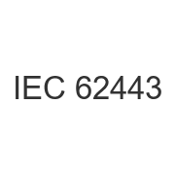
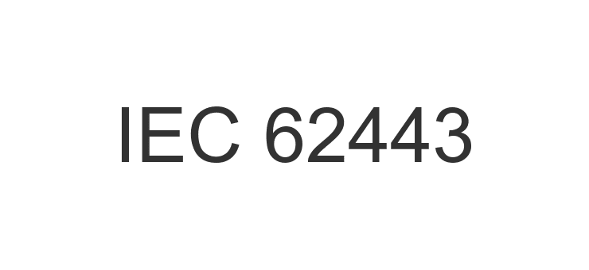
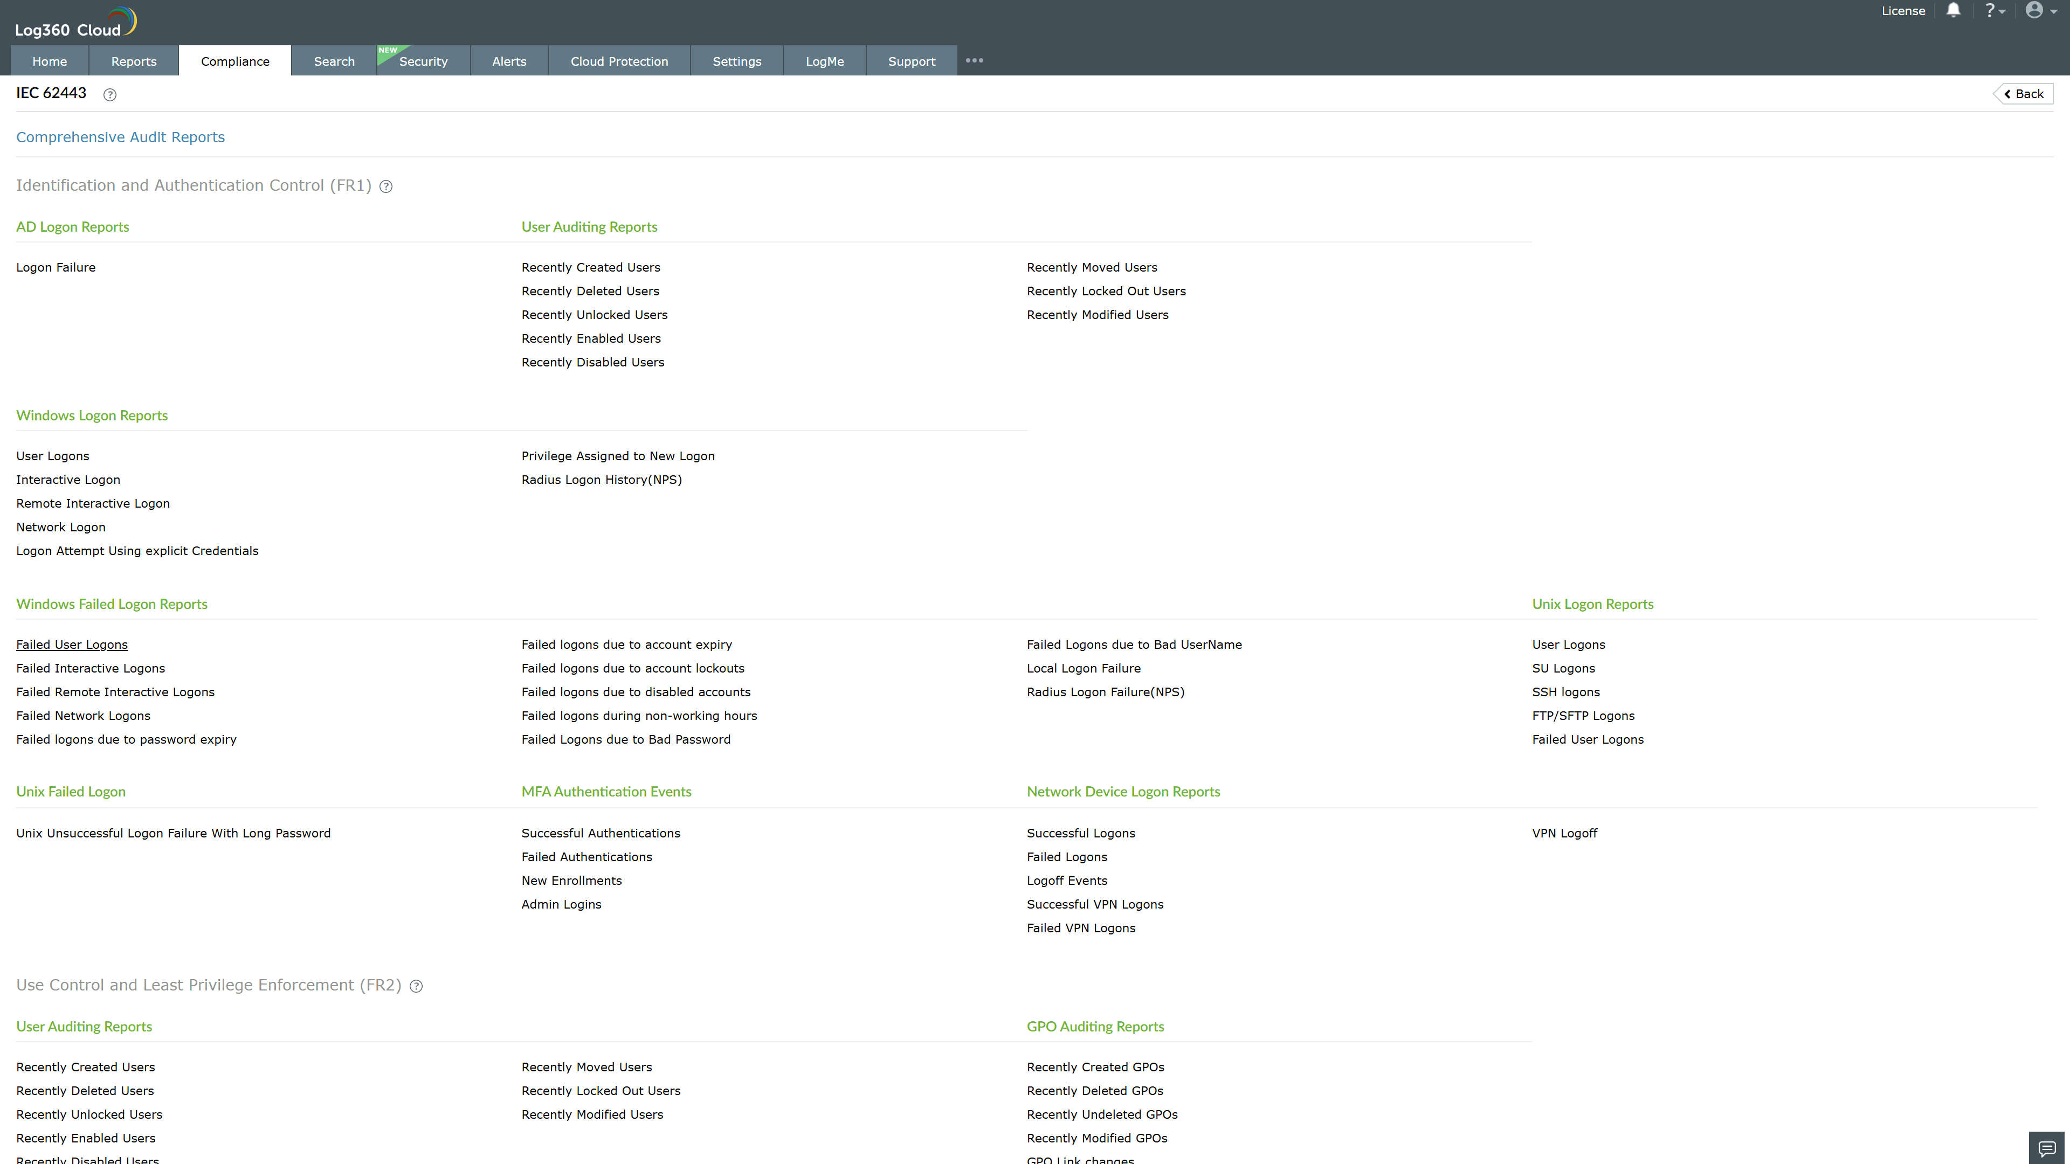
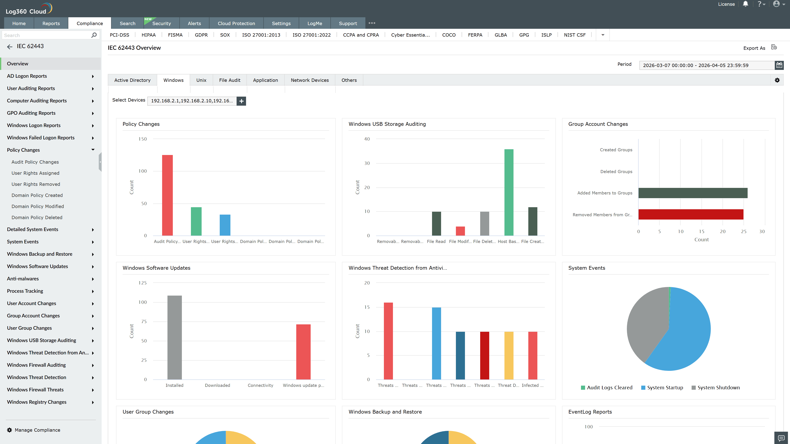
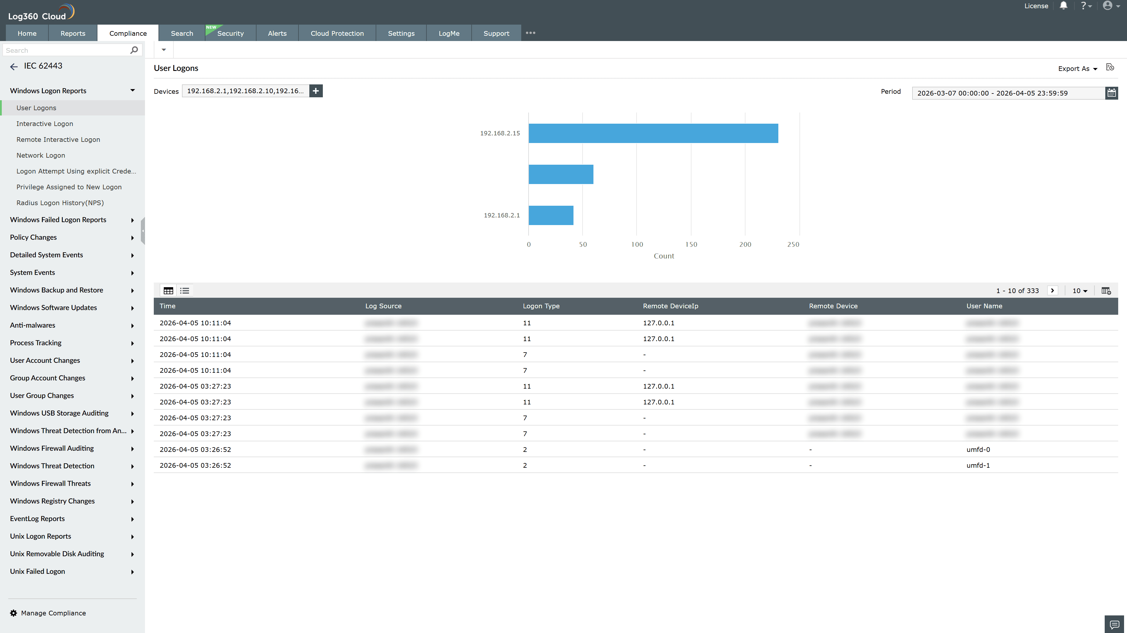
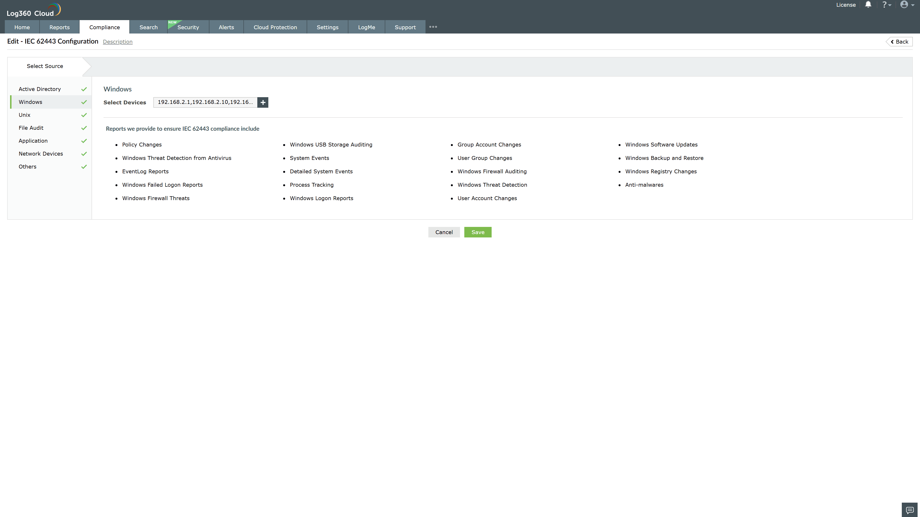
Valid Submission : Yes
Supported Editions : Free, Basic, Standard, Professional, MSSP
Help Document : https://www.manageengine.com/log-management/help/integrations/compliance-extensions.html
Help Video : Not provided
Tags : Log360, Compliance, Privacy monitoring, Data privacy, Regulatory compliance
Supported DCs : US, IN, JP, CA, AU, UK and EU
Privacy Policy:
Terms of Service:
Release Notes:
Predefined reports for the IEC 62443.

